

JULY 2021

P R O J E C T R E P O R T

PREPARED BY
RAMANJANEYA REDDY

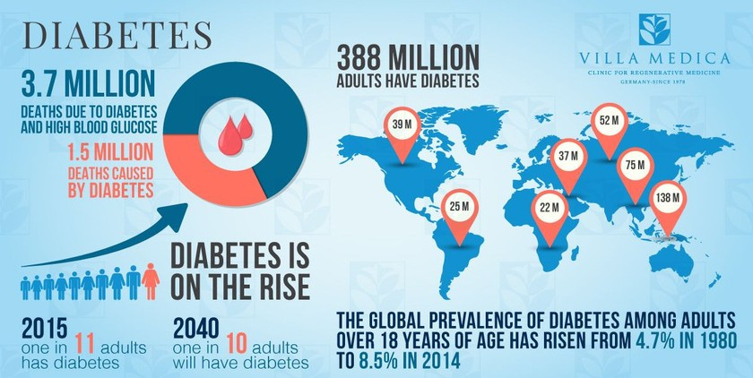
ABSTRACT
The first WHO Global reports on diabetes demonstrates that the number of adults living with diabetes has almost quadrupled since 1980 to 422 million adults. This dramatic rise is largely due to the rise in type 2 diabetes and factors driving it include overweight and obesity.In 2020 alone diabetes caused 1.5 million deaths. Its complications can lead to heart attack, stroke, blindness, kidney failure and lower limb amputation. The new report calls upon governments to ensure that people are able to make healthy choices and that health systems are able to diagnose, treat and care for people with diabetes. It encourages us all as individuals to eat healthily, be physically active, and avoid excessive weight gain. This project help us to Predict whether the patient is diabetic or not at early stage by using Conventional Machine Learning Algortihms and Reduce the risk of Succumbing to the Diabetes.
KEYWARDS: Algorithms, Dabetes,Machine Learning



Table of Contents

- Introduction
- Machine Learning Techniques
- Proposed method with Architecture
- Methodology

- Implementation

- Results

- Conclusion

Introduction
Health sector have large volumes databases. Such databases may be unstructured Semi-Structured,structured data .Bigdata analytics is the process which analyses huge data sets and reveals hidden information,hidden patterns to discover knowledge from the given data.Considering the current scenario, in developing countries like India, Diabetic Mellitus (DM) has become a very severe disease. Diabetic Mellitus (DM) is classified as Non-Communicable Disease (NCB) and many people are suffering from it. Around 425 million people suffer from diabetes according to 2017 statistics. Approximately 2-5 million patients every year lose their lives due to diabetes. It is said that by 2045 this will rise to 629million.DiabetesMellitus(DM)is classified as-Type-1 known as Insulin-Dependent Diabetes Mellitus (IDDM). Inability of human’s body to generate sufficient insulin is the reason behind this type of DM and hence it is required to inject insulin to a patient.

Type-2 also knowns Non-Insulin-Dependent Diabetes Mellitus (NIDDM). This type of Diabetes is seen when body cells are not able to use insulin properly. Type-3 Gestational Diabetes, increase in blood sugar level in pregnant woman where diabetes is not detected earlier results in this type of diabetes. DM has long term complications associated with it. Also, there are high risks of various health problems for a diabetic person. By using Predictive Analysis, incorporates a variety of machine learning algorithms, data mining techniques and statistical methods that uses current and past data to find knowledge and predict future events. By applying predictive analysis on healthcare data, significant decisions can be taken and predictions can be made.
Predictive analytics can be done using machine learning techniques. Predictive analytics aims at diagnosing the disease with best possible accuracy and enhancing patient care .

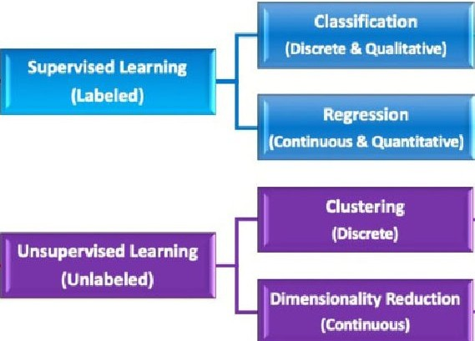 Machine LearningTechniques

1..Supervised Learning - Data is labelled
2. UnSupervised Learning - Data is not labelled

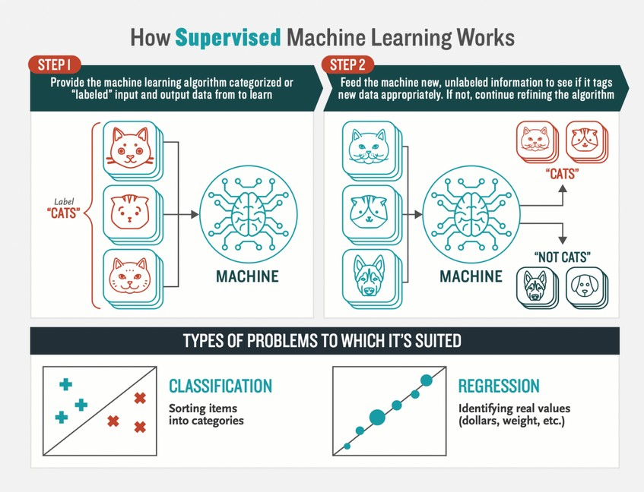Supervised Learning

A learning algorithm that works with data that is labelled
For example learning to classify fruits with labelled images of fruits as apple, orange, lemon, etc.

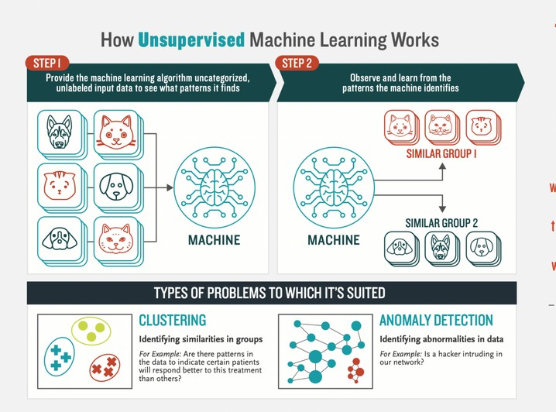

Unsupervised Learning

Unsupervised Learning: is a learning algorithm to discover patterns hidden in data that is not labelled
An example is segmenting customers into different clusters.

MACHINE LEARNING

SUPERVISED LEARNING

CLASSIFICATION kEGRE55lON
UNSUPERVISED LEARNING

CLUS7ERING

Linaor R ession,

Discrimin‹xst
Analysis

Naurol Networks
SYR GPB

En errd>l‹ Methods

Naurol Malworks
Hier‹schicol

Hidden Markov

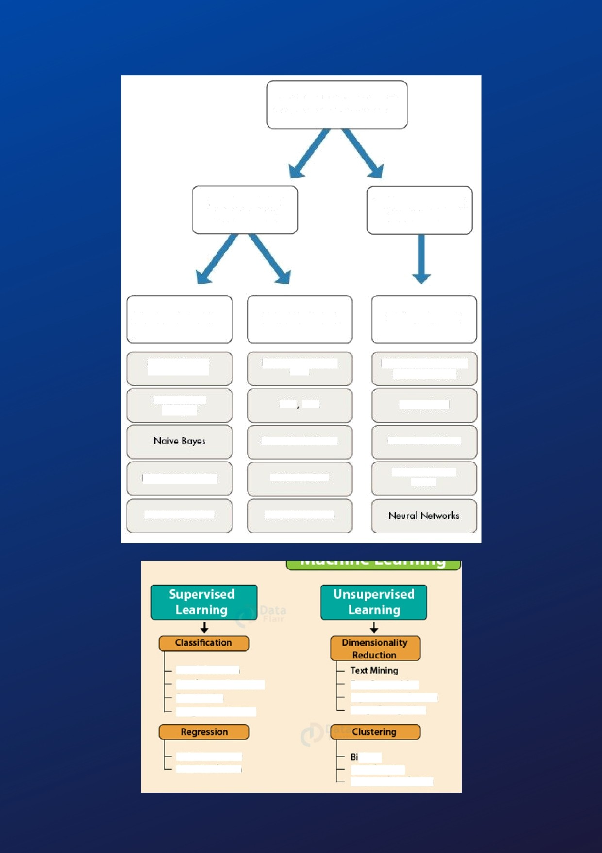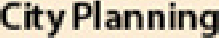
Fraud detectlon
Emag Spam Detection Diagnostics
Imaga Classification

Seore Pzedlctlon

Face BeaognMon
Big Data Viwalbation Image Reougnition

7azgetted Marketlng

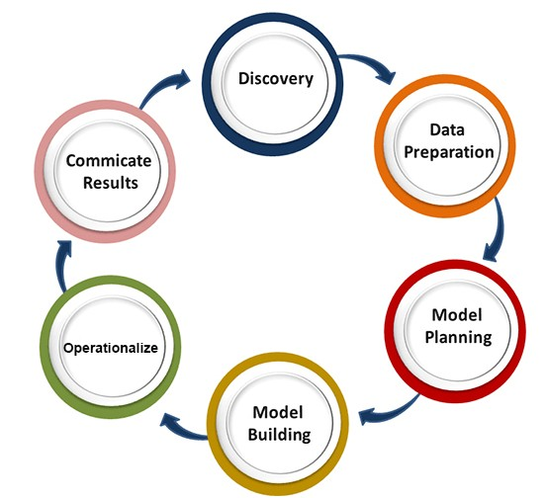Proposed method with Architecture
In Implementing any Machine Learning Algorithms we need to follow the following six steps as shown in below figure

Data Discovery

The important step for building any ML model is data collection from various resources .
In this project I used Diabetes data from Kaggle data set and we can also collect data from UCI Repository etc.
It is structured data and aligned well . If data is Unstructured or semi structured then we need to change it into structured data

Data Preparation & Visualization

In this step we clean and get insights from our data by various methods
If data contains Nan values, we can do it my removing row containing Nan values , by replacing Nan values with mean values of corresponding Columns.
If data contains outliers we can use robust scaling ,log transformation .
By using plots like Scatter ,Dist ,Box Plot we visualise and get insights from data which help us build model.

Model Planning
In this step we analyse the problem and we select the algorithms to perform on our data .
In this project , we need to predict whether the patient is diabetic or not which is discrete variable .
So we use classification algorithms to classify our target variables.
We use Supervised Learning techniques like Decision Tree,KNN,Naive Bayes .

Model Building
This is the crucial step for building a good ML Model.
In this we build Various model which suit to our data and problem .
Here we divide our data into train and test data to train and test our Model.
And build the model and apply to our data .

5 . Operationalizing
Here we apply our ML models to data and get the results.
Here we can use K fold cross validation and Grid Search.
And deploy our model as per our needs

6 . Communicate Results and Improving Performance
This most import phase for building model.
In this steps we use various methods such as tuning parameters and hyperparameters and apply different model if needed.
We increase the performance of model by increasing the amount of data.
If our model is overfitting or underfitting then we increase or decrease our data. Finally we use this model to predict in our real life problems.

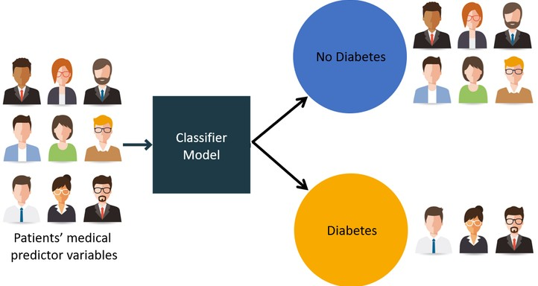Methodology
Algorithms Used
- Decision Tree Classifier
- Logistic Regression
- K - Nearest Neighbourhood
- Suport Vector Machine
- Naive Bayes
- Ada Boost
- Random Forest

- Decision Tree Classifier
The tree has three types of nodes.
A root node has no incoming edges and zero or more outgoing edges.
Internal nodes, each of which has exactly one incoming edge and two or more outgoing edges.
Leaf or terminal nodes, each of which has exactly one incoming edge and no outgoing edges.
In terms of decision tree induction, root and internal nodes are called attribute test conditions (Splits). And, leaf (or) terminal nodes are class labels.
Three main methods for selecting the best split
Entropy,GiniIndex Classification error.

- Logistic Regression
Logistic regression is used in classification problems where the labels are a discrete number of classes.
In classification we want the class label to be 0 (or) 1.

Hypothesis representation in logistic regression.

In linear regression, we represent the hypothesis as g( )= 1/1+
This equation is called sigmoid function.
A sigmoid function takes the values between 0 and 1.

3.K Nearest Neighbour
The KNN algorithm assumes that similar things exist in close proximity. In other words similar things are near to each other. KNN captures the idea of similarity .
In KNN we try to find neighbours of a given element and try to get inference those elements.
The typical way to find neighbours of a given element is by using various distance formulas
An element is classified by a majority
vote of its neighbours, with the element being assigned to the class most common amongst its K nearest neighbours measured by a distance function.

4 .Support Vector Machines

SVM is a supervised machine learning algorithm. SVM is most popular classification technique.
SVM creates a hyper plane that separate two classes.
It can create a hyper plane or set of hyper plane in high dimensional space. This hyper plane can be used for classification. SVM differentiates instances in specific classes and can also classify the entities which are not sup-ported by data.
Separation is done through hyper
plane that performs the separation to the closest training point of any class in our data

- Naive Bayes
Naive Bayes classifiers are a collection of classification algorithms based on Bayes’ Theorem.

Bayes Theorem finds the probability of an event occurring given the probability of another event that has already occurred.
Bayes’ theorem is stated as follow
P(A|B) = {P(B|A) P(A)}/{P(B)}
Basically, we are trying to find probability of event A,
P(A) is the priori of A
P(A|B) is a posteriori probability of B, i.e. probability of event after evidence is seen.

- AdaBoost Classifier
AdaBoost is one of the ensemble boosting classifier.
It combines multiple weak classifiers to increase the performance of classifiers.
The basic concept behind Ada boost is to set the weights of classifiers and training the data sample in each iteration such that it ensures the accurate predictions of unusual observations.
It should meet two conditions:
The classifier should be trained interactively on various weighed training examples.
In each iteration, it tries to provide an excellent fit for these examples by minimizing training error.

- Random Forest
It is type of ensemble learning method and also used for classification .
The accuracy it gives is grater then compared to other models. This method can easily handle large datasets.
Random Forest improve performance of Decision Tree by reducing variance and bias.
Here no of week classifiers are build. These Week random forest classifiers are used for building strong classifier. Here selection of depth of tree play a major role in building a good model .
It is best model among all the Machine Learning Models .

Implementation
By following below steps we build ML Models and Improve model Performance .
Step 1: Import the necessary packages and the reguired data set .
Step 2: Pre-processing the data by handling the missing values and outlies , Zeros with various methods .S
Step 3 : Visualizing the data by using various
plots likes box , dist and getting insights from data which helps to improve model performance.
Step 4: Splitting the data into training and test
data for training and testing the model. with 70 - 80 % and 30 - 20%.
Step 5 : Select the ML algorithms which suits to
our problems like supervised or unsupervised or Regression or classification or clustering .
Here we have to use classification techniques like Random Forest and Adaboost etc.

Step 6:
Building the different Machine Learning Models and fitting the training data to
them

Step 7: Testing the performance of models by using test data .
Step 8 : Using various performance metrics like
Accuracy, Recall , Precision , F1 - Score and confusion matrix to analyse the performance of the model .
Step 9: If our model is not performing well the
we have to use k - fold cross validation , Grid Search to improve performance of the model .
Step 10 : Finally, selecting the model which
performs well on our data .

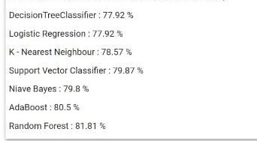Results
The performance of different models is as shown in figure

Conclusion
From the above models , Random Forest classifier is performing well.
This results can help to predict the patient is diabetic or not.
By using this models we can help the doctors and patients to get early diagnostic from diabetes.

